**Name:- Samreen Shaikh Roll no:- 64**

**Subject:- Big Data Analytics Date:- 05/02/2025**

**PRACTICAL - 14**

**PIG INSTALLATION AND OPERATIONS**

**INSTALLATION:**

**STEP I : *Install Pig from the link given below.***

**<https://downloads.apache.org/pig/pig-0.17.0/>**

**STEP II: *Setup path for pig in system variables.***

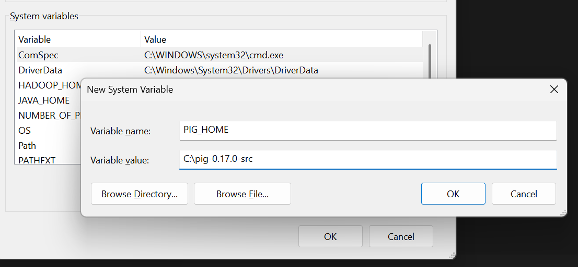

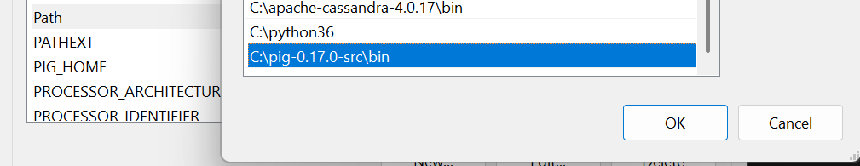

**STEP III: *Open Command Prompt from the bin directory of the pig folder.***

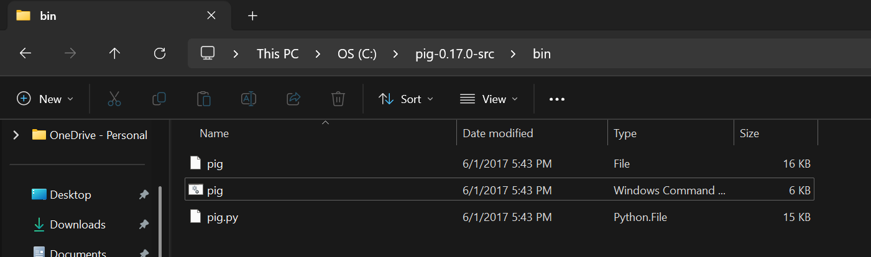

**STEP IV: *Type following to start the grunt shell.***

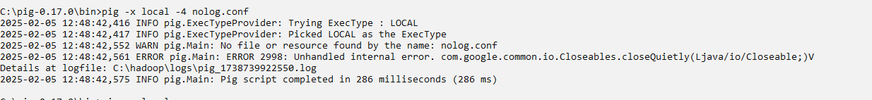

**OPERATIONS:**

**1] Loading the file**

**FILE USED**

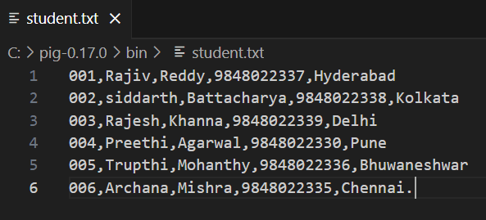

**CODE:**



**OUTPUT:**

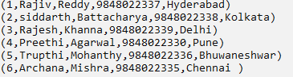

**2] Describe**

**CODE & OUTPUT:**



**3] Illustrate**

**CODE:**



**OUTPUT:**



**4] Group by city**

**CODE:**



**OUTPUT:**

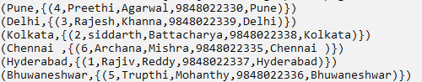

**5] Describe group**

**CODE & OUTPUT:**



**6] Illustrate group**

**CODE:**



**OUTPUT:**

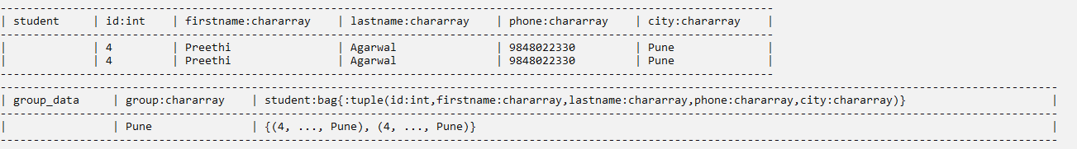

**7] Group multiple students**

**CODE:**



**OUTPUT:**

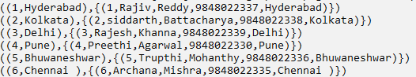

**8] Group All Students**

**CODE:**



**OUTPUT:**

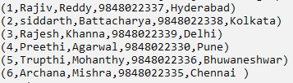

**10] Co group**

**FILE USED:**



**CODE:**







**OUTPUT:**



**11] Self join**

**FILE USED:**

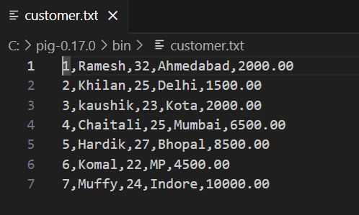

**CODE:**

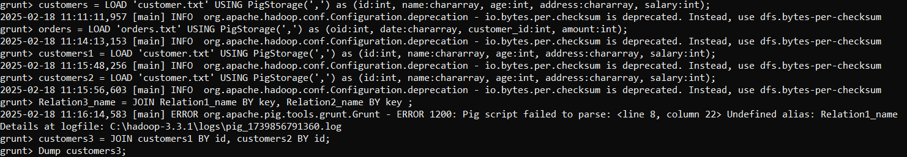

**OUTPUT:**

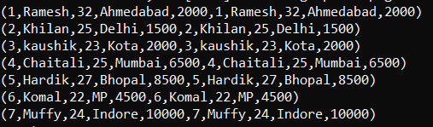

**12] Inner join**

**CODE:**





**OUTPUT:**

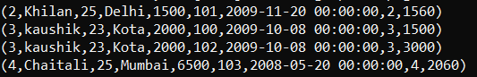

**13] Left outer joint**

**CODE:   
**

**OUTPUT:**

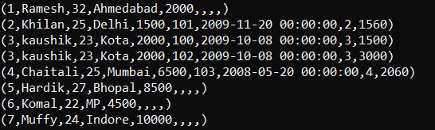

**14] Right outer joint**

**CODE:**



**OUTPUT:**

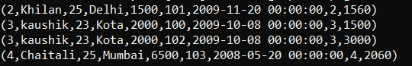**\**

**15] Full outer join**

**CODE:**



**OUTPUT:**

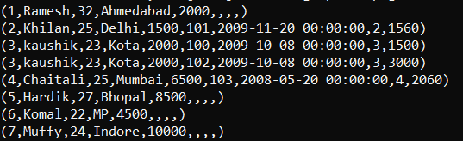

**16] Multiple Joins**

**FILES USED**

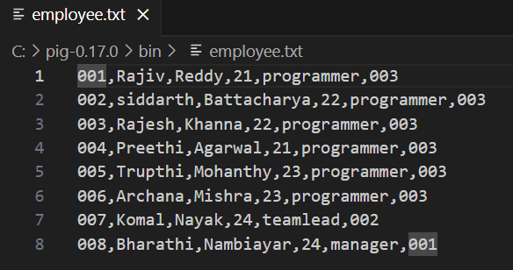

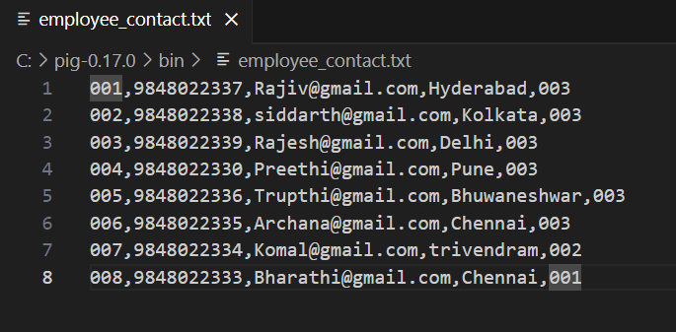

**CODE:**



**OUTPUT:**

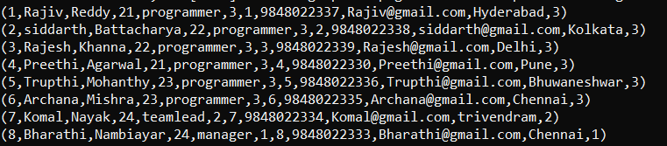

**17] Cross operator**

**FILE USED**



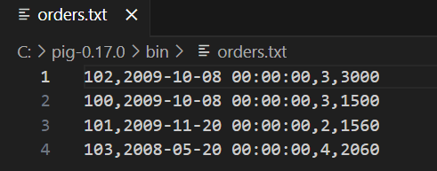

**CODE:**



**OUTPUT:**

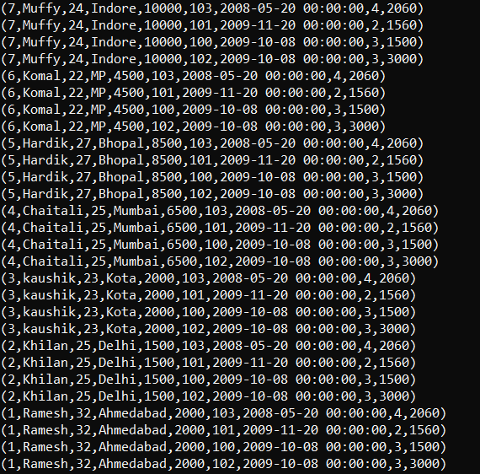

**18] Union**

**FILE USED:**



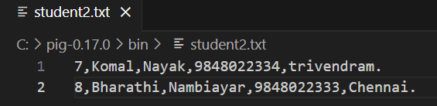

**CODE:**



**OUTPUT:**

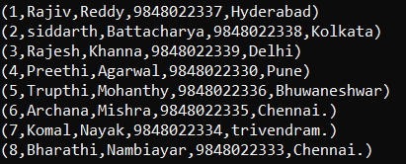

**19] Split operator**

**FILE USED:**

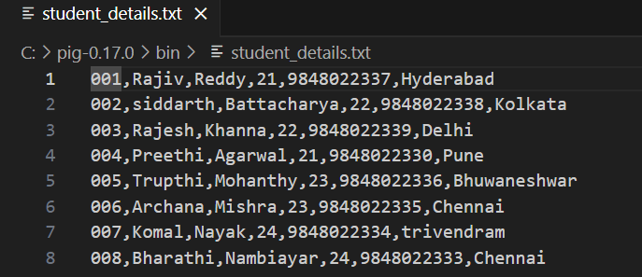

**CODE:**



**OUTPUT:**



